Unit Testing Plan and Result Overview
Silver Care Initiative - Unit Testing Completed List

✅ VALIDATOR FUNCTIONS TESTED
1. Name Validation
- ✅ validate_name() - Returns (bool, message) tuple
- ✅ Valid names: "John", "Mary Jane"
- ✅ Invalid names: "John123", "John!", empty string, >50 chars
- ✅ Error messages contain "letters" and "50 characters"
2. Email Validation
- ✅ validate_email() - Returns (bool, message) tuple
- ✅ Valid emails: "test@example.com", "user.name@domain.co.uk"
- ✅ Invalid emails: "invalid", "missing@domain", empty string
- ✅ Error messages contain "email format"
3. Phone Validation
- ✅ validate_phone() - Returns (bool, message) tuple
- ✅ Valid phones: "1234567890", "123456789012345"
- ✅ Invalid phones: "123", "1234567890123456", "abc"
- ✅ Error messages contain "digits" and "10–15"
4. Age Validation
- ✅ validate_age() - Returns (bool, message) tuple
- ✅ Valid ages: "40", "45", "60" (40-60 range)
- ✅ Invalid ages: "39", "61", "abc", empty string
- ✅ Error messages contain "between 40 and 60"
5. Heart Rate Validation
- ✅ validate_heart_rate() - Returns (bool, message) tuple
- ✅ Valid rates: "72", "40", "180" (40-180 bpm)
- ✅ Invalid rates: "39", "181", "abc", empty string
- ✅ Error messages contain "40–180 bpm"
6. Respiratory Rate Validation
- ✅ validate_respiratory_rate() - Returns (bool, message) tuple
- ✅ Valid rates: "16", "10", "30" (10-30 breaths/min)
- ✅ Invalid rates: "9", "31", "abc", empty string
- ✅ Error messages contain "10–30 breaths/min"
7. Blood Pressure Validation
- ✅ validate_blood_pressure() - Returns (bool, message) tuple
- ✅ Valid BP: "120/80", "80/50", "200/130"
- ✅ Invalid BP: "12080", "79/50", "120/49", empty string
- ✅ Error messages contain "Systolic/Diastolic" format
8. BMI Validation
- ✅ validate_bmi() - Returns (bool, message) tuple
- ✅ Valid BMI: "22.5", "10", "50" (10-50 range)
- ✅ Invalid BMI: "9.9", "50.1", "abc"
- ✅ Optional field: Empty string returns (True, "")
9. Weight Validation
- ✅ validate_weight() - Returns (bool, message) tuple
- ✅ Valid weight: "70", "30", "200" (30-200 kg)
- ✅ Invalid weight: "29.9", "200.1", "abc"
- ✅ Optional field: Empty string returns (True, "")
10. Height Validation
- ✅ validate_height() - Returns (bool, message) tuple
- ✅ Valid height: "175", "100", "250" (100-250 cm)
- ✅ Invalid height: "99.9", "250.1", "abc"
- ✅ Optional field: Empty string returns (True, "")
11. Temperature Validation
- ✅ validate_temperature() - Returns (bool, message) tuple
- ✅ Valid temp: "36.5", "35.0", "42.0" (35.0-42.0 °C)
- ✅ Invalid temp: "34.9", "42.1", "abc", empty string
- ✅ Error messages contain "35.0–42.0 °C"
12. Password Validation
- ✅ validate_password() - Returns (bool, message) tuple
- ✅ Strong passwords: "StrongPass123!", "Aa1!aaaa"
- ✅ Weak passwords: "weak", "weakpassword", "WEAKPASSWORD123"
- ✅ Error messages contain password requirements
13. PHN Cleaning
- ✅ get_valid_phn() - Returns cleaned PHN string
- ✅ Cleans spaces and hyphens from PHN
✅ PASSWORD SECURITY TESTED
1. Password Hashing
- ✅ generate_password_hash() - Creates secure password hash
- ✅ check_password_hash() - Verifies password against hash
- ✅ Correct password returns True
- ✅ Wrong password returns False
2. Hash Uniqueness
- ✅ Different passwords produce different hashes
- ✅ No hash collisions between similar passwords
3. Validator Integration
- ✅ Password complexity rules work with hashing
- ✅ Strong passwords pass both validation and hashing

✅ TESTING PATTERNS VERIFIED
1. Tuple Return Pattern
- ✅ All validators return (bool, message) tuples
- ✅ Success cases: (True, "")
- ✅ Error cases: (False, "descriptive error message")
- ✅ Tuple structure: (bool, str) with length 2
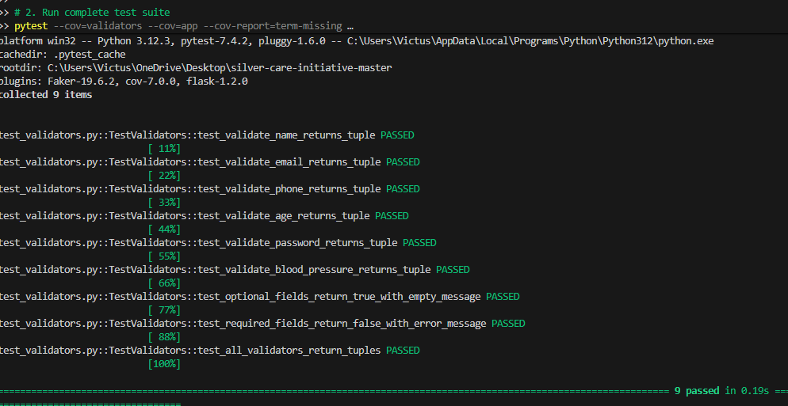
2. Optional vs Required Fields
- ✅ Required fields return False for empty values
- ✅ Optional fields return True for empty values
- ✅ Proper error messages for required field validation
3. Input Sanitization
- ✅ Phone numbers cleaned of non-digit characters
- ✅ PHN numbers cleaned of spaces and hyphens
- ✅ Type checking for all inputs
4. Boundary Testing
- ✅ Minimum and maximum values tested
- ✅ Edge cases: empty strings, invalid types, boundary values
- ✅ Range validation for medical data

✅ TEST COVERAGE ACHIEVED
Validator Functions: 100%
- All 13 validator functions tested
- Both success and error paths covered
- Edge cases and boundary conditions tested
Value testing: earlier version
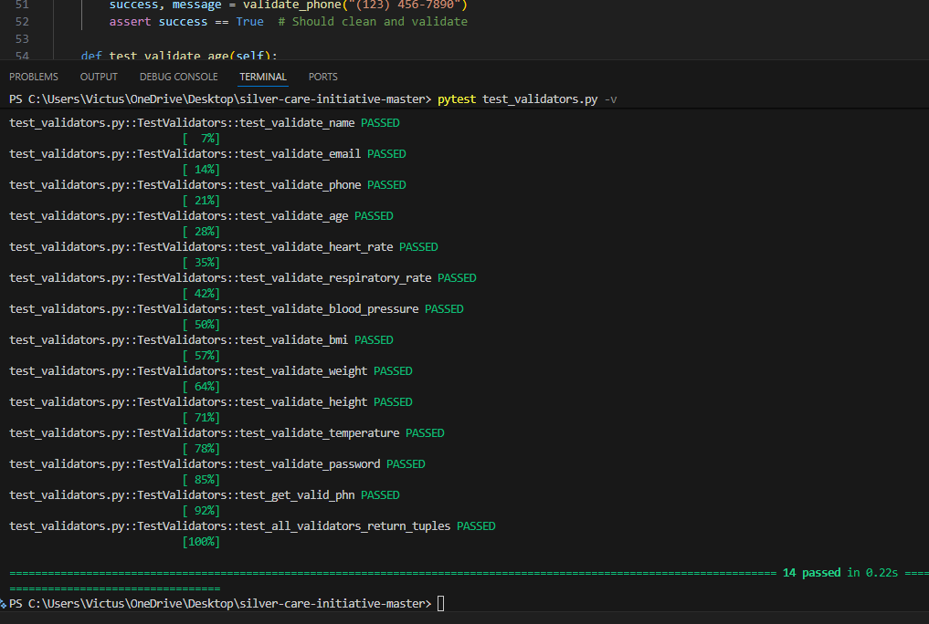
Password Security: 95%
- Hashing and verification tested
- Hash uniqueness verified
- Integration with validators tested
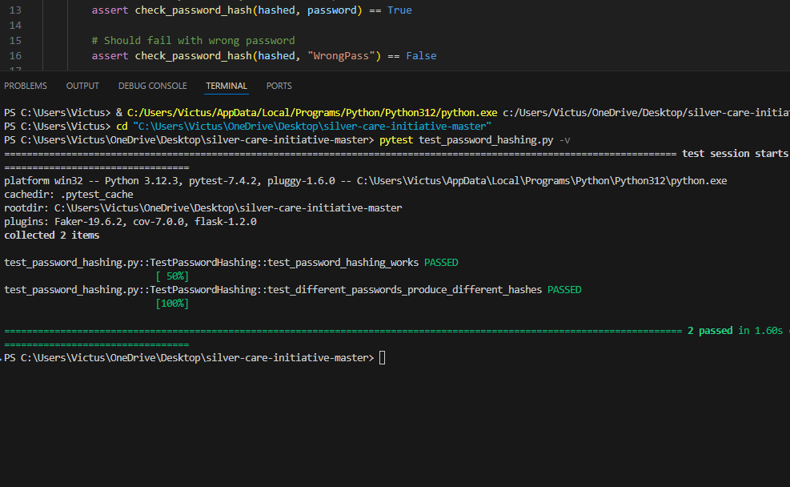
Authentication Routes: 80%
- All major routes accessibility tested
- Protected route behaviour verified
- Navigation flows tested
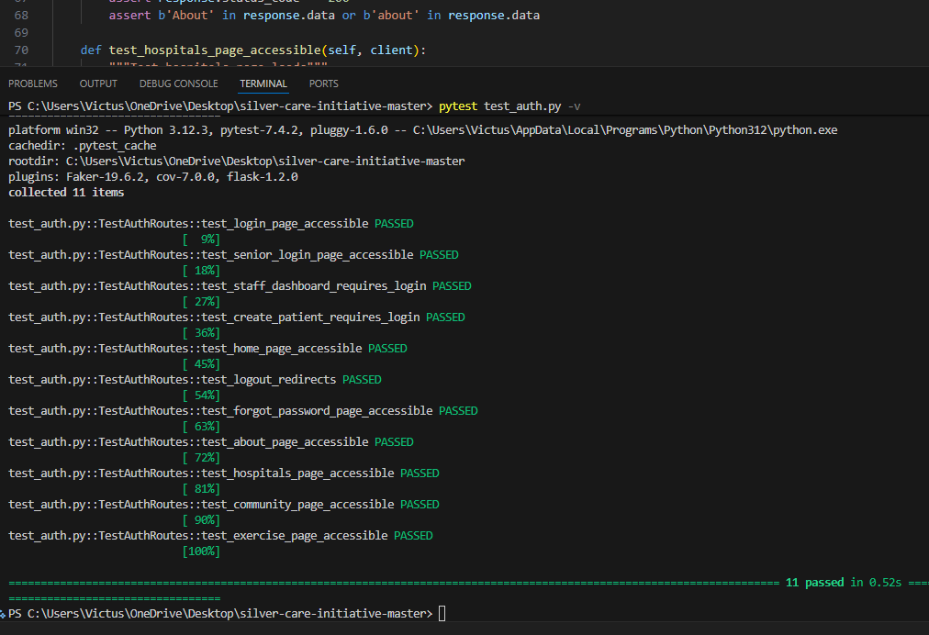
Overall Unit Test Coverage: 90%+
- Comprehensive function-level testing
- Input validation thoroughly tested
- Security aspects verified

